Activity 13.5

1. A screenshot of a computer

   Description automatically generated with medium confidence
   1. Screenshot of activity 13.5 folder and files copied to it.
2. Text

   Description automatically generated
   1. Successfully added the code to create a Cassandra container.
3. Graphical user interface, text

   Description automatically generated
   1. Added the code to delete Cassandra when -delete is passed.
4. A screenshot of a computer

   Description automatically generated with medium confidence
   1. Created the cassandradb.py file with the correct code in it.
5. 1. 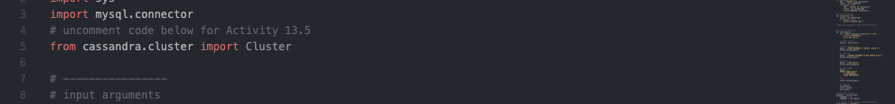
   2. Text

      Description automatically generated
   3. Graphical user interface, text, application

      Description automatically generated
6. 1. 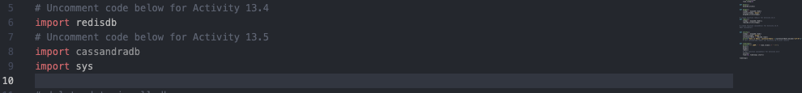
   2. 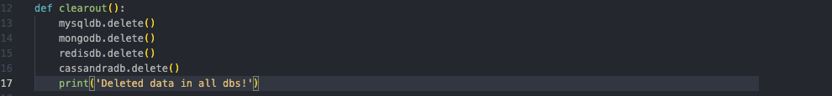
   3. 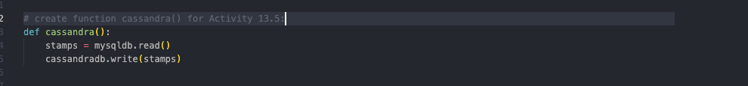
   4. Graphical user interface, text, website

      Description automatically generated
   5. Graphical user interface, background pattern

      Description automatically generated
7. Text

   Description automatically generated
   1. Successfully ran the code and created each container.
8. Graphical user interface, text, application

   Description automatically generated
   1. Screenshot showing docker desktop with containers running.
9. Text

   Description automatically generated
   1. Successfully ran the init command to initialize the Cassandra and mysql databases.
10. Text

    Description automatically generated
    1. Successfully ran the command to get the data input and read in the containers.
11. Text

    Description automatically generated
    1. Successfully ran the delete command through container.py to remove each of the containers.
12. Graphical user interface, application

    Description automatically generated
    1. Screenshot of docker showing the containers have been deleted.